Janick Bernet

Dominik Käser

Christian Oberholzer

29.05.2009

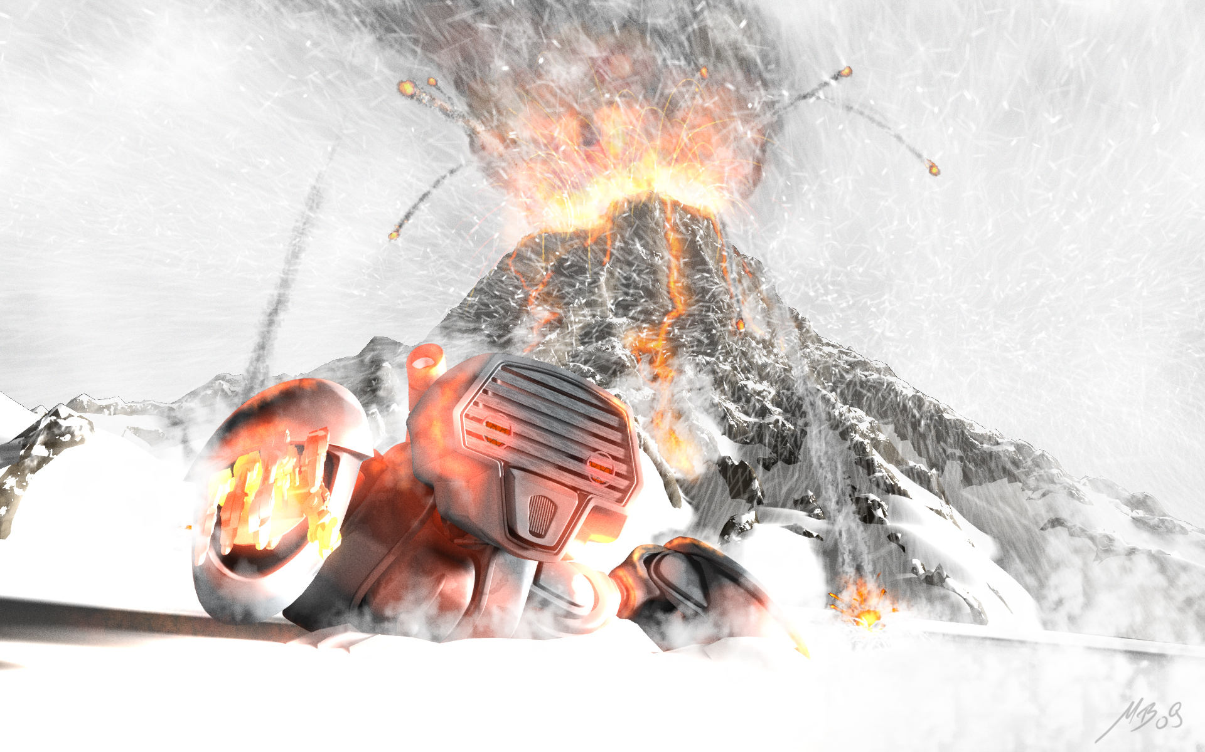

Game Notebook

Magmageddon

Table of Contents

[Table of Contents 2](#_Toc231647942)

[Part 1 – Formal Game Proposal 5](#_Toc231647943)

[Intro 5](#_Toc231647944)

[Informal Description 5](#_Toc231647945)

[Overview 5](#_Toc231647946)

[Game elements 5](#_Toc231647947)

[Concept Sketches 8](#_Toc231647948)

[Formal Requirements 12](#_Toc231647949)

[General 12](#_Toc231647950)

[GUI AND HUD 12](#_Toc231647951)

[Lava 12](#_Toc231647952)

[Pillars 12](#_Toc231647953)

[Floating Islands 13](#_Toc231647954)

[Player 13](#_Toc231647955)

[Development Schedule 14](#_Toc231647956)

[Deliverables 15](#_Toc231647957)

[Milestones 16](#_Toc231647958)

[Task Assignments and Work Estimation 17](#_Toc231647959)

[Development Timetable 19](#_Toc231647960)

[Assessment 20](#_Toc231647961)

[Part 2 – Prototype 22](#_Toc231647962)

[Gameplay Screenshots 23](#_Toc231647963)

[Findings 24](#_Toc231647964)

[Positioning 24](#_Toc231647965)

[Player movement 24](#_Toc231647966)

[Island Travel 25](#_Toc231647967)

[Parameter Tuning 25](#_Toc231647968)

[Part 3 – Interim Report 26](#_Toc231647969)

[Week 1: Functional Minimum 26](#_Toc231647970)

[Changes 26](#_Toc231647971)

[achievements 26](#_Toc231647972)

[Problems 26](#_Toc231647973)

[The Product 26](#_Toc231647974)

[Week 2: Low Target Part 1 27](#_Toc231647975)

[Changes 27](#_Toc231647976)

[achievements 27](#_Toc231647977)

[Problems 27](#_Toc231647978)

[Screenshots 28](#_Toc231647979)

[Production Example - Collision Detection 30](#_Toc231647980)

[Overview 30](#_Toc231647981)

[Broad Phase 30](#_Toc231647982)

[Collision Volumes 30](#_Toc231647983)

[Production Example –Creating Lava Surfaces 31](#_Toc231647984)

[First Approach: Lava planes 31](#_Toc231647985)

[Going beyond planes: Parallax Occlusion Mapping 32](#_Toc231647986)

[Part 4 – Alpha Release 35](#_Toc231647987)

[The Product 35](#_Toc231647988)

[Changes 35](#_Toc231647989)

[Achievements 35](#_Toc231647990)

[Problems 36](#_Toc231647991)

[Production Examples 36](#_Toc231647992)

[Environment 36](#_Toc231647993)

[HUD 37](#_Toc231647994)

[Animations 37](#_Toc231647995)

[Multithreading 38](#_Toc231647996)

[Particles 39](#_Toc231647997)

[Part 5 – Playtesting 41](#_Toc231647998)

[Participants 41](#_Toc231647999)

[Test sessions 41](#_Toc231648000)

[Questions Asked 41](#_Toc231648001)

[Play Matrix 41](#_Toc231648002)

[Overall Concept Comprehension 42](#_Toc231648003)

[OVERALL IMPLEMENTATION Questions 43](#_Toc231648004)

[Specific Implementation Questions 44](#_Toc231648005)

[sample question sheet 46](#_Toc231648006)

[Our own observations during the testing sessions 46](#_Toc231648007)

[Conclusions 47](#_Toc231648008)

[Impressions 48](#_Toc231648009)

[Part 6 – Conclusion 50](#_Toc231648010)

[The Product 50](#_Toc231648011)

[Changes 50](#_Toc231648012)

[Features 51](#_Toc231648013)

[The Feel 51](#_Toc231648014)

[Statistics 52](#_Toc231648015)

[Conclusion 53](#_Toc231648016)

[Overall 53](#_Toc231648017)

[Janick Bernet 53](#_Toc231648018)

[Dominik Käser 54](#_Toc231648019)

[Christian Oberholzer 54](#_Toc231648020)

[Screenshots 55](#_Toc231648021)

Part 1 – Formal Game Proposal

# Intro

For reasons still being researched, volcanoes started to appear all over Antarctica, flushing resources of unprecedented value onto the earth's surface. Although the resources legally belong to the state of Antarctica, the immense value of said resources led other fractions to claim ownership. Day after day, new gatherers arrived, trying to capture as much as they could. As the situation got out of control, the world union decided to legally distribute the resources all over the planet. In a time of great decadence it was decided that shares shall be dispensed based on the outcomes of deadly robot-matches inside the volcanoes. Since then, engineers all over the world have constantly been working on improving their robots in order to be able to explore and to claim the deadly depths of Antarctica's volcanoes.

# Informal Description

## Overview

The game features 2-4 players competing against each other (mainly in death match, but other modes such as control point or capture-the-flag are also conceivable) on one screen, viewed from a fixed angle (no scrolling, but automatic zoom has to be tested). The screen wraps around: if a player leaves to the right he will enter from the left and vice versa.

The competition takes place around a lake of lava. Large pillars stick out of the lava into the sky. Between the pillars, there are islands hovering on different heights. The players can stand on these islands, change the paths of the islands and go from one island to another. Islands can collide with each other and pillars, which can result in islands and/or pillars falling down and taking other objects with them. When a player stands on an island, it will slowly lose height because of the added weight. If a player leaves the island before it eventually sinks into the lava, it hovers back to its original position. Sunken islands can be replaced by new ones using a ray of cold water. Periodically, eruptions from the lava in the form of fireballs will appear and hurt players if they get hit.

## Game elements

### Environment

The game environment consists of a rectangular field where all the action takes place. The borders wrap around, meaning that everything disappearing on one side reappears on the other side. This battle ground basically consists of the following three different elements:

* A sea of lava covers the ground and is - of course - deadly to the players
* Rock pillars of different sizes stick out of the lava
* Rock islands hover on a specific height above the field of lava.

A more precise definition of these elements follows.

### Pillars

Pillars just stick out of the lava. Islands can collide with them and tilt them over. When a pillar falls, it can take other pillars or islands with it. On the top, the pillars are covered in ice which is constantly melting – therefore, water runs down along the pillars.

### Hovering islands

Islands hover on a specific height (Y axis) on a specific path between the pillars. When islands collide with each other or pillars, they are only deflected from their path on the XZ plane and never leave their fixed position on the Y axis. Players can stand on islands, but they will slowly lose height and eventually melt in the lava below. Islands are covered by grass and other flora. Islands in the upper heights can also be covered in ice.

### Player characters

Players control characters, which have a certain amount of health and energy. A player can move between the islands and attack other players. While melee attack is free, energy is consumed if a player performs some special attack (see Indirect combat (Chicken tactics)). Health is deduced when a player gets hit by another players attack. If a player’s health is zero or below, he dies and loses. A player also dies when falling into the lava.

### Power-ups

Simple power ups for health and energy are distributed over the islands. They will randomly re-appear if collected.

### Player Interactions

Every player can perform the following actions without using any finite resource:

#### Walking (boring but necessary)

Players can walk around the islands, though they cannot fall from them just by walking.

#### Collect power-ups (red bull gives you wings!)

If a player gets in contact with a power-up he can collect it and will receive the power accordingly.

#### Island attraction (Use the Force, Luke)

Islands can be attracted using some fancy force which makes them slowly move towards the island the player is standing on, so he can switch to the other island.

#### Island jump (Up and at them)

The player can activate his jet pack for a very short amount of time which allows him to go from one island to another.

#### Island repulsion (Gassy emission)

The player can change the path of an island either temporarily or completely. He does so by grasping the island and emits a burst of air using his jet pack.

#### Direct combat (Mano-a-Mano)

Every player has a melee attack ability which costs no energy. A melee attack will both deduce health from his enemy as well as physically push the opponent away from the attacker. The latter one can be exploited to push an opponent over the edge of an island.

Furthermore, every player has energy as a resource. Energy will recharge itself with time and can be used to perform the following actions:

#### Indirect combat (Chicken tactics)

A player has various means of indirect combat in the form of special abilities:

* **Ice spike**: The player can specify a direction in which, subsequently, a spike is sent off. If the spike hits an enemy, he will get hurt and frozen for a short period. If the spike hits lava, an island will be created.
* **Snow storm**: The player can specify a point in range; a cloud will appear and start snowing on the creatures below it, causing damage.
* **Fire wall**: The player can lighten up a fire on the floor which will remain there for a fixed amount of time. Players stepping on the fire will be hurt.
* **Small robot spawning (aka binary fission)**: The player can spawn a robot on the current island which will be there for a fixed amount of time and attack all enemies stepping on the island.

## Concept Sketches

### Typical In-Game Situation

On this image one sees:

* 4 pillars
* 3 Islands floating, two of them on the same height
* Estimated collision point between the green and the brown island. After the collision, they will change their movement direction.
* Players are visualized by rectangles. Player 1 sits on the brown island waiting to shoot at player 2. Player two on the other hand flees from the crash onto the blue island.

### islands_overdrawn3b.jpgVisual Impression

How the game could look when it is done.

### Perspective Studies

|  |  |  |
| --- | --- | --- |
| 77_mid.pngAn alternate view angle of 18 degrees. It is difficult here to navigate in the XZ plane. | 31_high.pngAn alternate tilt angle of 38 degrees. The notion of height is difficult to grasp here. | |
| 31_mid.pngWe deemed this view to be optimal in both perspective (f=21) and tilt angle (26 degrees ). | | |
| 21_mid.pngAn alternate perspective, f=21. The distortion is too large, players would stay in the front. | | 31_low.pngA more orthographic perspective, f=71. There is no dramatics, the look and feel is too static. |

### player_animations.pngModel Animation States

A finite state automata model of player animations. Colors denote priorities of realization (green is high, red is low). Outlined states denote looping animations.

### ROBOT MODELS

We particularly like the look and feel of this robot we found on the web. The head is over proportional to the body which yields a more comic look and feel. We might want to go for a longer head to make it look more aggressive, though.





A concept of little prop robots which are spawned on islands to make an island hostile (high target).

# Formal Requirements

## General

|  |  |  |
| --- | --- | --- |
| **ID** | **Requirement** | **Description** |
| ReqG01 | Basic Camera | The basic camera captures the scene from a predefined position. The whole game area is always visible. |
| ReqG02 | Advanced Camera | The camera films the scene from a varying position. It always films from the same side, but height an zoom may vary depending on the optimal setting. |
| ReqG03 | Basic Software Framework | Setting up a generic framework that is expandable, embeds the game logic, graphics and similar. The framework should be built as much on XNA as possible. But still every new feature should be addable as a separate component. |
| ReqG04 | HDR Rendering | Setting up the renderer to render with high definition textures and effects. This feature significantly improves the visual appearance of the game. |
| ReqG05 | Shadow Rendering | Rendering the scene with shadows using a state-of-the art technique. |
| ReqG06 | Statistics | Keep track about players win and looses, their longest live, their fastest kill and their fastest death. |

## GUI AND HUD

|  |  |  |
| --- | --- | --- |
| **ID** | **Requirement** | **Description** |
| ReqUI01 | Start Screen | There is a start screen from where one can start a new game and view the high score. |
| ReqUI02 | High Score | The high score features statistics (defined in Req06) about past games. |
| ReqUI03 | Text Input | Text can be entered using the controller. |
| ReqUI04 | Player Selection | Players can select their desired character and enter their name. |
| ReqUI05 | Map Selection | The first player can select a map to play in. |
| ReqUI06 | Simple HUD | A HUD showing each players health and energy has to be available. |
| ReqUI07 | Fancy HUD | A beautifully designed HUD that nicely integrates with the game environment has to be available. |
| ReqUI08 | Intro | An intro explains the game’s background story. |

## Lava

|  |  |  |
| --- | --- | --- |
| **ID** | **Requirement** | **Description** |
| ReqL01 | Lava Ground | The ground is covered by lava. This requirement represents the game-logic of the lava. |
| ReqL02 | Basic Lava Effect | A basic effect to render the lava lake. A basic red rectangle is enough for a first prototype. |
| ReqL03 | Polished Lava Effect | A polished and nice effect to render the lava lake. This includes advanced shaders. |
| ReqL04 | Deadly Lava | If the player gets into contact with the lava he dies. |
| ReqL05 | Fire Eruptions | At random there are fire eruptions emerging from the lake. |
| ReqL06 | Harmful Fire Eruptions | If such a fire eruption hits a player he endures damage or dies. If the eruption hits an island it throws the island off its course. |

## Pillars

|  |  |  |
| --- | --- | --- |
| ID | Requirement | Description |
| ReqPi01 | Pillars | Pillars of different sizes stick out of the lava. This requirement represents the need to model pillars with respect to in-game logic. |
| ReqPi02 | Basic Pillar Rendering | There is some model representing pillars which stick out of the lava. |
| ReqPi03 | Sophisticated Pillar Rendering | Realistically rendered pillars stick out of the lava. |
| ReqPi04 | Tilt Pillars | Pillars can be tilt over by islands. The resulting fall can affect other islands and pillars. |
| ReqPi05 | Icy Pillars | Pillars have a top consisting of ice, which melts to water that runs down the pillar and drops into the lava. |

## Floating Islands

|  |  |  |
| --- | --- | --- |
| ID | Requirement | Description |
| ReqI01 | Floating Islands | Initially there is a set of floating islands of rock. The islands hover above the lake of lava in different heights. |
| ReqI02 | Basic Island Rendering | A basic rendering such that the islands are visible and useable inside a game. |
| ReqI03 | Sophisticated Island Rendering | A polished and nice effect to render the islands. |
| ReqI04 | Moving Floating Islands | Islands have the ability to move. They move with a given velocity. |
| ReqI05 | Crashing Islands | If an island crashes into another island the collision will be resolved according to physics. The resulting movement should be locked onto the x/z plane the resulting rotation only respective to the y-axis. |
| ReqI06 | Islands and Pillars | If an island crashes into a pillar the collision will be resolved according to physics. The resulting movement should be locked onto the x/z plane the resulting rotation only respective to the y-axis. |
| ReqI07 | Sinking Islands | If a player stands on an island it will lose height. |
| ReqI08 | Rising Islands | If the island does not carry the player it regains its original height. |
| ReqI09 | Melting Islands | If an island gets into contact with lava it melts. |
| ReqI10 | Destructible Islands | If an island takes enough damage, either by a players special ability or by falling pillars it will fall apart. |
| ReqI11 | Icy Islands | Islands hovering above a specific height are slightly or fully covered in ice. |
| ReqI12 | Power-Ups | Power-Ups are lying on the islands. |
| ReqI13 | Power-Up Re-spawn | Power-Ups re-spawn if consumed on a random island |
| ReqI14 | Island Health Indication | If islands are being destroyed by heat the progress of destruction shall be indicated by an increasing glow. |

## Player

|  |  |  |
| --- | --- | --- |
| ID | Requirement | Description |
| ReqP01 | Player | The player has to be represented within the game-logic. |
| ReqP02 | Basic Player Model | A model for the player is available. |
| ReqP03 | Sophisticated Player Model | A realistic model for the player is available. |
| ReqP04 | Island Attraction | A player can use attract an island so it floats to the side of the island the player is standing on. As soon as the island is not attracted anymore, it hovers back to its original position. |
| ReqP05 | Island Walking | The player can walk to an island he attracted. |
| ReqP06 | Island Jumping | A player can use the jetpack to move from one island to another. |
| ReqP07 | Island Repulsion | A player can use the jetpack to emit bursts of air which will for a short period of time get an island to drift off its original course. If it collides with a pillar it could change its course completely. |
| ReqP08 | Direct Combat 1 | Every player has a melee attack ability which costs no energy. This will deduce health from his enemy. |
| ReqP09 | Direct Combat 2 | A realistic attack animation is displayed. |
| ReqP10 | Direct Combat 3 | Melee attacks will also physically push the opponent away from the attacker. |
| ReqP11 | Energy | Every player has an energy bar which is displayed in the UI. Energy will recharge itself with time. Every used skill will use a fixed amount of energy. |
| ReqP12 | Ice Spike | The player can specify a direction in which, subsequently, a spike is sent off. If the spike hits an enemy, he will get hurt and frozen for a short period. |
| ReqP13 | Flame Thrower Damage | The player can use a flame thrower to cause damage to another player. |
| ReqP14 | Flame Thrower Island Destruction | The player can use a flame thrower to target and destroy islands. |
| ReqP15 | Building Islands with Ice Spikes | If the spike hits a rising fire ball, an island will be built. |
| ReqP16 | Snow storm | The player can specify a point in range, a cloud will appear and start snowing on the creatures below it, causing damage. |
| ReqP17 | Fire Wall | The player can lighten up a fire on the floor which will remain there for a fixed amount of time. Players stepping on the fire will be hurt. |
| ReqP18 | Small Robot Spawning | The player can spawn a robot on the current island which will be there for a fixed amount of time and attack all enemies stepping on the island. |
| ReqP19 | Aiming Aids | Visual aids for helping the player aim (during ranged combat or islands jumping) shall be implemented to simplify controlling a player. |
| ReqP20 | Collecting Power-Ups | Players can collect power-ups and get their respective bonuses. |
| ReqP21 | Slow Indication | If a player has been slowed, this state shall be indicated graphically. |

# Development Schedule

The development shall be divided into consecutive layers. All of the requirements defined under are classified and assigned to one of them. Those layers are:

1. **Prototype**: The prototype serves to play test the central game-logic and contains only the most minimal graphical features needed to represent the game state. If any feature is removed from this part the prototype will degrade from a game into a technical prototype.
2. **Functional minimum**: This first layer contains the set of requirements minimally required to play the game and also some first simple visuals. The functional minimum is the first milestone.
3. **Low target**: The low target is the second layer and also a milestone. Though it contains more features than the bare minimum, it is still essentially not what should be achieved during the timeframe of fourteen weeks. Still it will serve as a good indicator if the development is still inside the timeframe laid out in this chapter.
4. **Desirable target**: This layer and milestone is what the project aims at. It contains all the requirements that make up a well polished and fun to play game.
5. **High target**: The high target contains additional features that will make it into the final deliverable if the team has some free time to implement them. There is no milestone defined for it. After finishing the Desirable Target it will be decided which features of this target will make it into the gold version milestone.
6. **Extras**: This part of the schedule defines some additions to the game that would be fun but are not realistic to achieve. However in a future project they could be added.

The layers then are assigned to milestones to be reached on a specific date. Those milestones contain a detailed timetable determining when each requirement will be implemented and who is responsible for the implementation. This timetable shall be filled out iteratively during the projects development.

## Deliverables

### Prototype

|  |  |
| --- | --- |
| ID | Requirement |
| ReqG01 | Basic Camera |
| ReqG03 | Basic Software Framework |
| ReqL01 | Lava Ground |
| ReqL02 | Basic Lava Effect |
| ReqL04 | Deadly Lava |
| ReqPi01 | Pillars |
| ReqPi02 | Basic Pillar Rendering |
| ReqI01 | Floating Islands |
| ReqI02 | Basic Island Rendering |
| ReqI04 | Moving Floating Islands |
| ReqP01 | Player |
| ReqP02 | Basic Player Model |
| ReqP06 | Island Jumping |
| ReqP08 | Direct Combat 1 |
| ReqP10 | Direct Combat 3 |
| ReqP12 | Ice Spike |
| ReqI12 | Power-Ups |
| ReqP20 | Collecting Power-Ups |

### Functional Minimum

|  |  |
| --- | --- |
| ID | Requirement |
| ReqI05 | Crashing Islands |
| ReqI06 | Islands and Pillars |
| ReqP09 | Direct Combat 2 |
| ReqI07 | Sinking Islands |
| ReqI08 | Rising Islands |
| ReqP13 | Flame Thrower Damage |
| ReqP14 | Flame Thrower Island Destruction |
| ReqP11 | Energy |
| ReqUI06 | Simple HUD |
| ReqP19 | Aiming Aids |
| ReqG05 | Shadow Rendering |

### Low target

|  |  |
| --- | --- |
| ID | Requirement |
| ReqL03 | Polished Lava Effect |
| ReqPi03 | Sophisticated Pillar Rendering |
| ReqI03 | Sophisticated Island Rendering |
| ReqP03 | Sophisticated Player Model (may be moved) |
| ReqUI04 | Player Selection |
| ReqUI07 | Fancy HUD |
| ReqI14 | Island Health Indication |
| ReqP21 | Slow Indication |
| ReqP04 | Island Attraction |
| ReqP05 | Island Walking |
| ReqI13 | Power-Up Re-spawn |

### Desirable target

|  |  |
| --- | --- |
| ID | Requirement |
| ReqP07 | Island Repulsion |
| ReqUI01 | Start Screen |
| ReqUI05 | Map Selection |

### High target

|  |  |  |
| --- | --- | --- |
| ID | Requirement | |
| ReqG04 | HDR Rendering | |
| ReqL05 | Lava Eruptions | |
| ReqL06 | Harmful Fire Eruptions | |
| ReqPi04 | Tilt Pillars | |
| ReqPi05 | Icy pillars | |
| ReqI09 | Melting Islands | |
| ReqP15 | Building Islands with Ice Spikes | |
| ReqUI08 | Intro | |
| ReqG06 | Statistics | |
| ReqUI03 | Text Input | |
| ReqUI02 | High Score | |
| ReqG02 | | Advanced Camera |

### Extras

|  |  |
| --- | --- |
| ID | Requirement |
| ReqI10 | Destructible Islands |
| ReqP16 | Snow Storm |
| ReqP17 | Fire Wall |
| ReqP18 | Small Robot Spawning |
| ReqI11 | Icy Islands |

## Milestones

|  |  |  |  |
| --- | --- | --- | --- |
| ID | Milestone | Description | Due Date |
| MS01 | Prototype Chapter Written | With this milestone the prototype chapter must have been written and added to the game notebook. Everyone in the team should also have installed and experimented with XNA in order to be ready for development.  Additionally a game prototype according to the prototype specification has been created. | March 16, 5pm |
| MS02 | Functional Minimum | With this milestone the functional minimum must be implemented, working and tested. | March 23, 12pm |
| MS03 | Interim Report Written | With this milestone the chapter with the interim report must have been written and added to the game notebook. | April 6, 5pm |
| MS04 | Low Target | With this milestone the low target shall be hit. | April 13, 12pm |
| MS05 | Desirable Target | With this milestone the team must have fulfilled the requirements for the desirable target. The prototype must be tested and in presentable order since it is needed for play testing in the week after. | May 4, 12pm |
| MS06 | Play test Chapter Written | With this milestone the play test chapter must have been written and added to the game notebook. This concludes that to this date all the play testing must be done. | May 11, 5pm |
| MS07 | Gold Version | With this milestone the development must have been concluded. All testing must have been finished and some of the high target functionality should be implemented. | May 25, 12pm |
| MS08 | Conclusion and Presentation | With this milestone the conclusion chapter must have been written and added to the game notebook. In addition the public presentation of the game must be ready to be held. | May 29, 5pm |

## Task Assignments and Work Estimation

### Prototype

|  |  |  |  |
| --- | --- | --- | --- |
| ID | Requirement | Assignee | Work Estimate |
| ReqG01 | Basic Camera | cob | 2h |
| ReqG03 | Basic Software Framework | cob | 8h |
| ReqL01 | Lava Ground | jab | 3h |
| ReqL02 | Basic Lava Effect | cob | 2h |
| ReqL04 | Deadly Lava | jab | 3h |
| ReqPi01 | Pillars | cob | 3h |
| ReqPi02 | Basic Pillar Rendering | cob | 2h |
| ReqI01 | Floating Islands | jab | 2h |
| ReqI02 | Basic Island Rendering | dpk | 4h |
| ReqI04 | Moving Floating Islands | jab | 4h |
| ReqP01 | Player | dpk | 10h |
| ReqP02 | Basic Player Model | jab | 4h |
| ReqP06 | Island Jumping | jab | 4h |
| ReqP08 | Direct Combat 1 | jab | 1h |
| ReqP10 | Direct Combat 3 | jab | 2h |
| ReqP12 | Ice Spike | jab | 3h |
| ReqI12 | Power-Ups | cob | 2h |
| ReqP20 | Collecting Power-Ups | cob | 1h |

### Functional Minimum

|  |  |  |  |
| --- | --- | --- | --- |
| ID | Requirement | Assignee | Work Estimate |
| ReqI05 | Crashing Islands | cob | tbd |
| ReqI06 | Islands and Pillars | cob | tbd |
| ReqP09 | Direct Combat 2 | jab | tbd |
| ReqI07 | Sinking Islands | dpk | tbd |
| ReqI08 | Rising Islands | dpk | tbd |
| ReqP13 | Flame Thrower Damage | jab | tbd |
| ReqP14 | Flame Thrower Island Destruction | cob | tbd |
| ReqP11 | Energy | jab | tbd |
| ReqUI06 | Simple HUD | jab | tbd |
| ReqP19 | Aiming Aids | dpk | 8h |

### Low Target

|  |  |  |  |
| --- | --- | --- | --- |
| ID | Requirement | Assignee | Work Estimate |
| ReqL03 | Polished Lava Effect | dpk |  |
| ReqPi03 | Sophisticated Pillar Rendering | dpk |  |
| ReqI03 | Sophisticated Island Rendering | dpk |  |
| ReqP03 | Sophisticated Player Model |  |  |
| ReqUI04 | Player Selection | jab | 3h |
| ReqUI07 | Fancy HUD | jab | 3h |
| ReqI14 | Island Health Indication | cob |  |
| ReqP21 | Slow Indication | cob |  |
| ReqP04 | Island Attraction | jab | 4h |
| ReqP05 | Island Walking | jab | 2h |
| ReqI13 | Power-Up Re-spawn | jab | 1h |
| None | Advanced Collision Detection | cob |  |
| None | Gamplay testing | jab | 4h |

### Desirable target

|  |  |  |  |
| --- | --- | --- | --- |
| ID | Requirement | Assignee | Comments |
| ReqL03 | Polished Lava Effect | dpk | performance |
| ReqPi03 | Sophisticated Pillar Rendering | Dpk | textures |
| ReqI03 | Sophisticated Island Rendering | Dpk | textures |
| ReqP03 | Sophisticated Player Model | dpk /cob |  |
| ReqUI07 | (Fancy HUD) | jab | need graphics from designer |
| ReqI14 | (Island Health Indication) | cob | depends on flamethrower |
| ReqP21 | Slow Indication | Dpk | In player shader |
| ReqP07 | Island Repulsion | Jab | implemented in MS03 |
| ReqUI01 | (Start Screen) |  |  |
| ReqUI05 | (Map Selection) |  |  |
| None | Advanced Collision Detection | Cob | Performance |
| None | Default robot in player selection | Jab |  |
| None | No-repeat in menu | Jab |  |
| None | Death indication in HUD | Jab |  |
| None | Flamethrower island selection? | Jab |  |
| None | Improved ice spike aiming + Sphere | jab/dpk |  |
| None | Last man standing gameplay mode | Jab |  |
| None | Powerup and arrow animation | Dpk |  |
| None | (Level preview in Menu) | Jab |  |
| None | Keyboard controls for player 1 | Jab |  |
| None | Ice spike effect (particle system) | Cob |  |
| None | Explosion effect (particle system) | Cob |  |
| None | Fire effect (particle system) | Cob |  |

## Development Timetable

Week 11: 9.3.-15.3. Working towards MS01

|  |  |  |  |  |  |  |  |  |  |
| --- | --- | --- | --- | --- | --- | --- | --- | --- | --- |
| ID | Requirement | Assignee | Mo | Tue | Wed | Thu | Fri | Sat | Sun |
| ReqG01 | Basic Camera | cob |  | 2 |  |  |  |  |  |
| ReqG03 | Basic Software Framework | cob | 8 |  |  |  |  |  |  |
| ReqL01 | Lava Ground | jab |  | 3 |  |  |  |  |  |
| ReqL02 | Basic Lava Effect | cob |  |  | 2 |  |  |  |  |
| ReqL04 | Deadly Lava | jab |  | 3 |  |  |  |  |  |
| ReqPi01 | Pillars | cob |  |  | 3 |  |  |  |  |
| ReqPi02 | Basic Pillar Rendering | cob |  |  | 2 |  |  |  |  |
| ReqI01 | Floating Islands | jab |  |  | 2 |  |  |  |  |
| ReqI02 | Basic Island Rendering | dpk |  | 4 |  |  |  |  |  |
| ReqI04 | Moving Floating Islands | jab |  |  |  | 4 |  |  |  |
| ReqP01 | Player | dpk |  | 4 | 4 | 2 |  |  |  |
| ReqP02 | Basic Player Model | jab |  |  |  | 4 |  |  |  |
| ReqP06 | Island Jumping | jab |  |  |  |  | 4 |  |  |
| ReqP08 | Direct Combat 1 | jab |  |  | 1 |  |  |  |  |
| ReqP10 | Direct Combat 3 | jab |  |  | 2 |  |  |  |  |
| ReqP12 | Ice Spike | jab |  |  |  | 3 |  |  |  |
| ReqI12 | Power-Ups | cob |  |  |  | 2 |  |  |  |
| ReqP20 | Collecting Power-Ups | cob |  |  | 1 |  |  |  |  |
| None | Testing | jab/dpk/cob |  |  |  |  |  | 4 | 4 |
| None | Work Estimates and Plan for MS05 | jab/dpk/cob |  |  |  |  |  | 1 | 1 |

Week 12: 16.3.-22.3. Working towards MS02

|  |  |  |  |  |  |  |  |  |  |
| --- | --- | --- | --- | --- | --- | --- | --- | --- | --- |
| ID | Requirement | Assignee | Mo | Tue | Wed | Thu | Fri | Sat | Sun |
| ReqG01 | Basic Camera | cob |  | 2 |  |  |  |  |  |
| ReqG03 | Basic Software Framework | cob | 8 |  |  |  |  |  |  |
| ReqL01 | Lava Ground | jab |  | 3 |  |  |  |  |  |
| ReqL02 | Basic Lava Effect | cob |  |  | 2 |  |  |  |  |
| ReqL04 | Deadly Lava | jab |  | 3 |  |  |  |  |  |
| ReqPi01 | Pillars | jab |  |  | 3 |  |  |  |  |
| ReqPi02 | Basic Pillar Rendering | cob |  |  | 2 |  |  |  |  |
| ReqI01 | Floating Islands | jab |  |  | 2 |  |  |  |  |
| ReqI02 | Basic Island Rendering | dpk |  | 4 |  |  |  |  |  |
| ReqP01 | Player | jab |  |  |  | 4 |  |  |  |
| ReqP02 | Basic Player Model | dpk |  | 4 | 4 | 2 |  |  |  |
| ReqP06 | Island Jumping | jab |  |  |  | 4 |  |  |  |
| ReqP08 | Direct Combat 1 | jab |  |  |  |  | 4 |  |  |
| None | Testing | jab/dpk/cob |  |  |  |  |  | 4 | 4 |
| None | Work Estimates and Plan for MS05 | jab/dpk/cob |  |  |  |  |  | 1 | 1 |

Week 13: 23.3.-29.3. Working towards MS03 and MS04

Exact schedule to be determined.

Week 14: 30.3.-05.4. Working towards MS03 and MS04

Exact schedule to be determined.

Week 15: 06.4.-12.4. Working towards MS04

Exact schedule to be determined.

Week 16: 13.4.-19.4. Working towards MS05

Exact schedule to be determined.

Week 17: 20.4.-26.4. Working towards MS05

Exact schedule to be determined.

Week 18: 27.4.-03.5. Working towards MS05

Exact schedule to be determined.

Week 19: 04.5.-10.5. Working towards MS06

Exact schedule to be determined.

Week 20: 11.5.-17.5. Working towards MS07

Exact schedule to be determined.

Week 21: 18.5.-24.5. Working towards MS07

Exact schedule to be determined.

Week 22: 25.5.-29.5. Working towards MS08

Exact schedule to be determined.

# Assessment

The game features various possibilities of interaction with the game world and other players. Thus, it offers a very varied game play and diverse tactics a player can employ in order to ingeniously defeat its opponent. On the other hand, it should still be simple enough for everyone to learn the controls in a matter of minutes and enjoy playing.

A game world mainly consisting of lava is a challenge, but should reward us - and the player - with a beautiful, animated environment. Additionally, there is some cool physics involved when islands collide with each other or pillars.

We regard the game to be successful if players can make real use of the floating islands - and the involved physics - to fight each other.

Part 2 – Prototype

This chapter describes a first software prototype of the main game mechanics and shows our findings based on its evaluation. The prototype already incorporates the following concepts of the final game:

* Pseudo-randomly moving islands with colliding pillar interactions.
* Players who can move in the XZ plane and jump from platform to platform using a jetpack.
* Long-range attacks of players using the ice spike skill.
* Melee attacks of players.
* Visualization aids assisting players to navigate in the 3D space using shadows.
* Power-ups which are placed on islands.

We decided to approximate all the game elements with very simple geometric primitives. Although later islands might not have a flat surface in the final game, this simplified contact and collision detection a lot. Their movement is based on two forces: First, they get attracted by all the pillars whereas the force is quadratic to the distance. Second, we add a random force in each frame to prevent them from converging at one point.

The player’s movement is divided into two parts: using the gamepads left analog-stick he can move in the XZ plane, while pressing A activates the jetpack allowing him to move up the y-axis. This movement is calculated by a simple acceleration of the jetpack, which is added to the player’s velocity vector in each time step. Gravity acceleration works against the jetpack and keeps a player standing on an island – and (in the worst case) falling down into the lava. If players walk into each other they receive a minor velocity-based pushback. A stronger pushback is encountered, if one player hits another.

Shadows are realized by real-time shadow maps. At the moment, they use no interpolation in the look-up stage which leads to very jagged artifacts at steep angles. However, the sole purpose of a shadow implementation at this stage was to determine whether or not shadows would serve well to support players navigating on the islands.

The ice spike implements a homing mechanism. After the spike is set off, the spike gets slightly pulled into the direction of an enemy. However, we have an upper bound for this force in order not to make aiming too easy.

For easier tracking of hits (either melee or through ice-spikes) appropriate sounds were also added.

Evaluation

We have tested the game (and will continue to do so a lot within the upcoming days) with respect to the following criteria:

* Is it easy and intuitive to move the player and perform attack actions?
* Does the core game play make fun, even after playing it for several minutes?

While the latter question is common and crucial for every game concept, the former one is one raised by multiple reviewers of our original concept. By testing this point in a very early phase, we want to react properly to the feedback we’ve got in the first stage.

# Gameplay Screenshots



Two players are standing on a moving island. Two collectable power-ups are on other islands. A player’s health, energy and fuel level is currently shown as a text label. Later, this will be replaced by a graphical HUD.



A player is shooting a bunch of ice-spikes, although missing his enemy.



A player is using his jetpack to move to the smaller, upper island. As visible in the text on top, using the jetpack needs fuel.

# Findings

## Positioning

It is still quite tough to position yourself in the 3D environment. To make the task easier, we added shadows to enable the player to look at the projection of the island and his robot to more easily track his position. To control a player hidden behind an island or another object, we will implement some feature showing his contours projected onto such an object. This could also be combined with shadowing in a way a player gets a marker on all islands below and above him.

The addition of shadows unfortunately leads to the problem that a player is completely in the dark and not visible. Nevertheless, this can easily be solved by having the player emit his own light and adding ambient lights.

Finally, we will have to do further experiments with the angle and focal length used for the camera to reduce positioning problems.

## Player movement

Currently, a player can walk off an island, which is a very unfortunate and leads to sudden death. It would make sense to only allow the player from falling of an island if he explicitly uses his jetpack or other means of traveling between the islands. Otherwise, He should not be able to walk beyond the edge of the island. We will implement this behavior in a further version.

## Island Travel

Using free jetpack movement, it is nearly impossible to move between islands, because of mentioned 3D positioning and tracking problems. Therefore, a more passive approach (like selecting the island and automatic flying) should be taken. This could also have the advantage that a player can look around and shoot spikes at his opponents while flying. Additionally, the path on which an island moves should be visualized in the future (for instance by small rings of dust). Therefore the path of an island will have to be fixed or at least calculated in advanced to visualize where an island will move to some time from now.

## Parameter Tuning

Without the need to drastically change certain implementations and aspects of the game, one can heavily improve the experience by tuning parameters (e.g. attack damage, gravity or jetpack acceleration). To simplify this task and in order to allow fast testing of different parameters, we implemented a game console which shows the state of all active entities on the screen and enables the user to directly manipulate them:



An in-game console which allows the modification of parameters and attributes of all the present entities.

Part 3 – Interim Report

This chapter describes how the game developed from an early prototype to nearly the finished low target. It describes step by step the work that has been done and the changes to the original planning and schedule that have been made.

# Week 1: Functional Minimum

## Changes

One change as been applied to the requirements fulfilled by Milestone 2. The team agreed to delay the requirement “ReqP09 – Direct Combat 2” to the next milestone since it was not possible to implement the attack visualization without having a player model.

## achievements

Compared to the prototype, the game has matured further. The major improvements that have been applied are in detail:

* ReqP13 and ReqP14: A new type of ranged weapon has been added: The flame thrower. Using the flame thrower, it is possible to either attack the opponent or to destroy islands. The flamethrower does not have the same range as the ice spike, but whatever is hit by its flames sustains heavy damage.
* ReqP12: The ice spike for which we had only a primitive implementation in the prototype has been redefined and improved. The aiming is now easier than before.
* ReqI07 and ReqI08: Islands now constantly lose height while carrying a player. As soon as a player jumps off the island it gradually regains its original height. This feature improves the dynamics of the game by making it faster.
* ReqI05: Islands can now collide with each other, allowing different islands on the same height.
* ReqUI06: The status strings have been replaced by a first and simple HUD.
* ReqP19: Failed

## Problems

The game still has several shortcomings. Some of them have been mentioned in detail in chapter two. This is a short summary of the persisting problems:

* Navigation is not trivial
* Ice spike aiming could be better
* The game play is overloaded and needs to be streamlined
* The collision response has to be improved in certain places

## The Product

The working product features the moving islands in an already well fleshed-out form, but without any textures. Movement between the islands is still restricted to the jetpack, while a new gadget, the flame thrower, is available. It can be used to harm players, or islands. The ice spike aiming has been improved, but is still lacking accuracy. Collision detection is only done using simple collision primitives (cylinders and spheres).

# Week 2: Low Target Part 1

## Changes

The realistic player model (ReqP03) has been moved to the desirable target, which further delays the direct combat animation (ReqP09). Some additional requirements were introduced, as a result of some additional play testing and findings from the prototype: ReqI14 is a new requirement for a visual indication of an island’s health (it should glow when it gets damaged by the flame thrower). Similarly, ReqP21 is the visual indication of a player’s frozen state (which could also be solved through the HUD). Also, ReqP04 (Island Attraction) has been extended to also include an easy way to jump from island to island.

## achievements

The game made a huge step forward in terms of visuals compared to the functional minimum. Also, the problems of inter-island traveling have been addressed quite successfully in the form of island jump. The collision detection is also much finer grained compared to the simple primitives of Milestone 2. In detail, those changes are:

* ReqL03: A shader for realistic Lava rendering has been written, described in-depth in the corresponding section.
* ReqPi03: More sophisticated pillar models have been included, though they are not textured yet.
* ReqI03: Three different island models have been included.
* ReqUI04: An in-game menu has been added which will allow the selection of maps and players.
* ReqP04: Islands can be selected using the right analog stick; the closest island in the direction the stick points at is selected and the player can attract that island by pressing the right trigger. He can jump to that island by pressing the left trigger.
* ReqP05: A player can walk – or fly using the jetpack – to an attracted island.
* ReqI13: Power-ups respawn on a random island after a random amount of time after consumption.

## Problems

Some problems still remain, such as:

* The collision response for standing on top of an island has some flaws; it can happen that a player oscillates on top of an island or gets set on top although he collided with the island’s border.
* Islands don’t collide with the cave at the back, nor are they stopped from leaving the screen to the left, right or bottom.
* On island attraction, some collision response is not correct: Islands can sometimes go through pillars.

Collision response was particularly problematic, as it can heavily depend on the frame rate: if the frame rate drops and the time step increases, objects can fall through or collide again after the application of collision response – and the same (maybe inappropriate) response gets applied again. Therefore, collision response has to be fine-tuned and adapted to each object interaction combination which will take up quite some time. This frame rate dependence may also mean that we will have to multi-thread our engine, so draw and update code can be run on separate cores und a low update time step can be guaranteed.

# Screenshots



The current game screen including the HUD.



The green player jumping towards the selected island.



The Menu overlay.

# Production Example - Collision Detection

## Overview

To implement the game code in Project Magma, some sort of collision detection between a set of entities (namely the player, power-ups, islands and pillars) was needed. As with all the other parts of the software, the target was to keep the collision detection pluggable and easy to configure. As with all features, this allows for reconfiguring the collision detection at runtime. This has the advantage that we can test different collision volumes for different entities.

In accordance to all the other parts of the software, a new property, a collision entity, and a collision manager was introduced. Collision entities represent a “collidable” entity within space bounded by a collision volume. They are stored inside the collision manager which also tests for collisions between the entities. The binding between the simulation on one side and the collision entities and the collision manager on the other side happens inside the collision property which is attached to an actual simulation entity that should collide with other entities.

## Broad Phase

Broad phase collision detection is currently not optimized. The collision manager uses the naïve approach testing each collision entity against each other entity.

## Collision Volumes

Collision detection supports three different types of volumes:

* Bounding spheres
* Bounding cylinders aligned to the unit y-axis
* Triangle trees. These are trees of axis aligned bounding boxes containing triangles inside the leaf nodes. Each leaf contains up to five triangles.

The content pipeline creates all three collision volumes for each triangle mesh. The level designer then chooses which bounding volume is assigned to a given entity.

# Production Example –Creating Lava Surfaces

## First Approach: Lava planes

We would like to show an example of a graphical element which we consider to be crucial for a credible ambience of our game. This serves both as a documentation for our own reference and for a work report for the lab.

We started our research in lava rendering by searching the web for tutorials describing how to create lava effects in offline rendering systems like Maya. We found <http://en.9jcg.com/comm_pages/blog_content-art-94.htm> to be the one with the nicest results and implemented it first in Maya and then as a GPU effect.



1 – An overlay of several fractal textures (Stucco) generated in Maya. Offsetting these with respect to each other will be used for animation. 2 – The dark parts of Stucco are replaced by a slight granite texture generated in Maya. 3a – We add diffuse shading to allow for normal mapping later on.

3b – Another fractal texture, generated in Maya and luminance-amplified in the shader. 4a – The fractal texture gets blended in and moves slowly over the plane which simulates moving fog. 4b/5a – A normal map is added to give the dark parts (stones) some structure. 5b/6 – Two cloud renderings, generated in Photoshop, are used to generate a pseudo-random field of UV vectors which are used to distort the texture coordinates. This simulates air flickering due to the heat. 7 – A final glow with Gaussian Blur is added.

We had to omit the displacement part for now, but we got everything else to work with some tweaking. We added the heat flickering effect as described above by slightly distorting the texture coordinates.

## Going beyond planes: Parallax Occlusion Mapping

The effect of the shader described above looks already quite pretty when seen from a perspective projection like the one in the picture to the left.

However, we had to find out that the effect owes much of its dramaticism to the wide-angle perspective we’ve used during the development of the shader. As discussed in an earlier chapter, though, our gameplay requires an almost orthographic view onto the scene in order to maintain maximal clarity for the players navigating in the scene.

After using the camera parameters from the game itself, much of the effect is lost (see right). First, the pattern appears to be much more monotonous than before, and suddenly we miss the notion of depth. Since the angle between the camera and the ground plane is relatively flat in our setting, we thought that it would be nice to have some actual geometric structure in the lava instead of just plain normal mapping. To find out if this would help, we took an implementation of Parallax Occlusion Mapping and included it into our shader.

As we show on the left, we regained a large part of the depth of the scene we’ve lost previously due to the perspective change.

At this point, we started to get more creative by altering parameters of the individual layers. We inverted, compressed or luminance-scaled the height map, introduced new color mappings and changed the strength of PO mapping. Soon, it became apparent that small changes in individual parameters led to under- or oversaturation quite fast, and the need for some simple global tone mapping arose. As we already had a post-processing stage, this was easy to implement and it turned out that a 3rd order Lagrange polynomial with interactively modifiable parameters already does the trick. On the next two pages, we show examples of results we achieved with different parameter sets.

An increasing issue of PO mapping became the performance. We are currently working on emulating the same effect with several planes, alpha maps and alpha testing.



First – the original shader, just with Parallax Occlusion Mapping enabled.

Second – a very big glow radius and low-contrast settings in the HDR post-processing stage.

Third – low glow radius but relatively high contrast settings in the post-processing stage.

Fourth – higher glow radius, intentional oversaturation to emphasize the perception of a very bright light source in the lava.





In this set, we inverted the depth effect of PO mapping by negatively scaling the occurring gradient term. The Stucco map which combines the textures (see earlier) is still unchanged, though.

First – low glow radius and strength, linear tone mapping.

Second – all illuminations are scaled up to create an uniformly hot surface.

Third – exaggerated contrast.

Fourth – even more exaggerated contrast. The black ridges can be interpreted as floating ashes.



In this set, we inverted the Stucco texture which serves as both a height map and a blending operator between texture layers. Afterwards, we let the Gradient unchanged, so the entire effect is just inverted.

First – low glow radius and strength, linear tone mapping.

Second – a very big glow radius and low-contrast settings in the HDR post-processing stage.

Third – enhanced contrast. The bright structures can be interpreted as little flames which move along the surface.

Fourth – extreme contrast. The flame effect is exaggerated now to indicate that the fire is really bright.



In this set, we inverted both the Stucco texture and its gradient afterwards. This leads to big, bright, burning chunks on the surface.

First – low glow radius and strength, linear tone mapping.

Second – a very big glow radius and low-contrast settings in the HDR post-processing stage.

Third – enhanced contrast.

Fourth – extreme contrast.

Part 4 – Alpha Release

# The Product

The current release features all items from the desirable target. Graphics-wise those are: Textured pillar and island models, textured cave, animated lava and a generic particle system used for the ice spike, the flamethrower and explosions. Furthermore there is a newly designed HUD and a menu screen. On the game play side we have moving islands, island attraction, island repulsion, ice spikes, the flamethrower and direct combat in the form of hits with pushback. HDR from the high target is also already implemented.

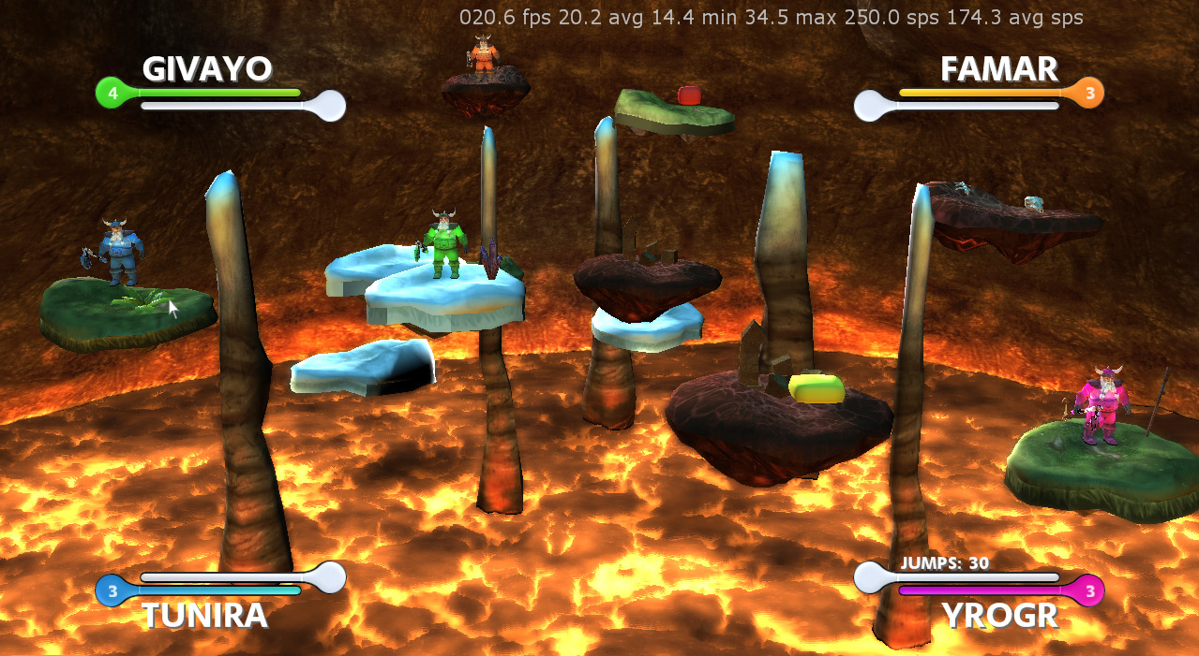

## Changes

Statistics (ReqG06) and high score (ReqUI02) have been moved into the high target. The default means of moving among the island has been changed from island jump (ReqP06) to island attraction (ReqP04). The jet pack can only be used when falling as a mean of saving one selves and doesn’t use any more fuel, as this has been removed as a resource. Island jumps have been restricted to certain distances. Island walking (ReqP05) has been replaced by island jumps after attraction. Island jumps over long distances and island repulsions are now only available through power ups. As a result of some testing, we streamlined the controls and put all means to move between islands (jump, attraction and jet pack) on one button – this will be evaluated further in the play testing phase. Furthermore, to improve performance we split rendering and simulation into two different threads.

## Achievements

Many features have been polished since the last milestone and are now visually pleasing and more usable. Those include:

* The lava effect (ReqL03) has been merged into the game, optimized and polished.
* Pillar and island models have been improved and textured. There are three island styles (burnt, icy and green) with different decoration.
* Power ups and selection arrows bounce in a sinus wave, so they can be spotted more easily
* The HUD has been completely redesigned and line with the streamlining of game play (only two bars: health and energy, indication of jumps and island repulsions).
* We created a particle system (see production examples) which has been used for the ice spike, and will soon be implemented in the form of explosion and burning effects.
* The ice spike’s aiming has been improved, it is now able to avoid islands and pillars to a certain degree to better hit its target.
* Islands which get attracted push away other islands in their path and quickly arrive at their destination, though deceleration slowly towards it.
* The general movement of islands has been improved and hovering back to their original path around a pillar has been implemented.
* The implementation of a multithreaded architecture (one thread for rendering, multiple for simulation and collision detection) resulted in a large performance boost (see production examples).

## Problems

Most of the bugs should be fixed until the alpha presentation of Tuesday and the play testing of this week. We track all existing bugs using our own Mediawiki. Our biggest problems right now are keeping the performance around 30fps and eliminating the jerkiness which can result from the decoupling of rendering and simulation.

# Production Examples

## Environment

The environment now features different elements in their final version which previously were only available as dummies:

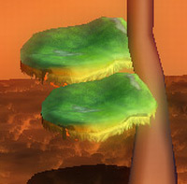First, we have different island models now which correspond to different altitudes inside the cave: There are grassy islands on a middle level, icy islands on the upper and burnt islands on the lower level. Using pixel shaders, we added some windy grass parts on the side of the grass islands. Also, we have new models for pillars which feature snow on the top to indicate that they are on a higher altitude. As for the lava, we decided to go for a variation of the third picture in the interim report chapter. The cave can be seen in the background as well.

2 islands next to a pillar.

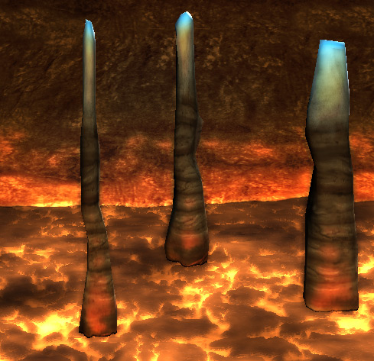All elements except the lava are shaded with a fully-functional Phong shader with individual extensions, lit by three directional light sources. The first light source is a warm orange from below to simulate elements lit by the lava. This one has a very fast decay as can be seen on the image below. The second light is a cold blue one from above, indicating daylight. By tuning these lights accordingly, we’ve been contributing to the contrast between cold and warm tones which we wanted to achieve right from the start. The third light source, finally, is a moving spotlight coming from behind. This emphasizes the feeling that the actors are actually fighting in an arena and increases the contrast in the border regions. It will be a new high target to add a moving spot light model to the cave wall to justify this particular light source.

Three pillars in the lava inside the cave.

## HUD

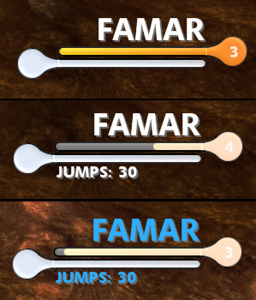We created a new version of the HUD which has a focus on simplicity and better visual integration into the whole scene. Also, we added some blinking effects whenever damage is sustained in order to increase the feeling of being hurt (analogously to red tinted screens in shooting games). When the player is frozen, his name blinks in blue tones. The number of lives is displayed as a number inside the health bar. Below the energy bar, the current power-up details (if any) are displayed.

The HUD is mirrored according to its position on the screen – this can be seen in the full-screen picture above. In terms of implementation, the bars consist of different monochromatic components which are colored and combined in a pixel shader.

The new HUD. Top: Full Health and Energy. Middle: Damage is being sustained at the moment. Bottom: Player is frozen.

## Animations

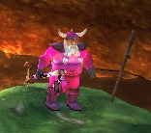We are using the XNA Animation Component Library (ACL) from <http://www.codeplex.com/animationcomponents> to animate the player characters. We had to change some parts of the library since our models now need to be processed by both our own processor as well as the ACL processor. As for models, we are currently using the standard dwarf model that is supplied with the library but we hope to get an own model into our game within the next weeks. In terms of coloring the players, we have an alpha map on the dwarf’s texture which indicates which parts of the model may be colorized how to what extent.

The animated dwarf character standing on an island.

## Multithreading

### Overview

Running Project Magma on only one of the three cores of the Xbox resulted in performance problems during the alpha phase. The obvious optimization was to divide the game into a rendering and a simulation thread since both used about the same amount of CPU time.

One suggested approach was not to care about synchronizing the two threads, but to just use the simulation data as-is inside the renderer. But this approach could lead to inconsistent frames and possibly some other more serious problems. Another possibility is to keep the data the renderer needs in two places. On one hand the simulation still owns the master data; on the other hand the renderer owns a copy of the data which is periodically updated. Using this concept synchronization can be achieved with a minimal amount of overhead.

### Technical Details

The technical realization of the mentioned approach is quite trivial. On the simulation side a set of renderer-stubs are installed. The simulation always updates the data that needs to be passed to the renderer on these stubs. These stubs record changes using change-objects in one queue per simulation frame. After the simulation frame is done some intermediate code passes the queue in a synchronized manner from the simulation to the renderer. Whenever the renderer wants starts to render a new frame it checks whether it has received new update-queues. If so, it applies the changes provided by the queues to its copies of the simulation-data. This results in the renderer being updated in a consistent manner with only one short point of synchronization, namely the passing of the update queue. In addition the creation and application of the update queues is usually not a huge performance hit since there are not that many changes due to temporal and local coherence. The memory overhead is also quite low because the renderer does not need that much data to be copied. Usually it only needs copies of position, rotation and scale.



The drawback of this approach is shown in the illustration on the right side. It visualizes the timeline of simulation and renderer frames. On each frame-change of the simulation (denoted with a vertical marker) some updates are passed to the renderer. If the simulation is running on an unstable, varying frame rate the situation might occur that the renderer has to render two consecutive frames using the same data. This can lead to a jerky frame rate which can result in the game appearing to run at a much lower frame rate. If, for instance, the renderer runs usually at about 30 frames per second the resulting sequence of pictures may look like the generated by a renderer running at half the speed (since some frames are really the same). We think that the solution to this problem lies in interpolating the values delivered by the simulation. Using interpolation we can avoid having to render the exact same frame twice, which should lead to a smooth animation of all the objects within the game.

## Particles

### Overview

The simulation and rendering of particles is a non-trivial problem. Especially the simulation of many thousands of particles on a computer’s or console’s CPU is not feasible because they are just not designed for such tasks. Thus some research was used to implement the particle system for Project Magma. The main sources of information are:

* “Building a Million-Particle System” by Lutz Latta, published on Gamasutra in 2004: <http://www.gamasutra.com/view/feature/2122/building_a_millionparticle_system.php> [1]
* “UberFlow: A GPU-Based Particle Engine” by Peter Kipfer, Mark Segal, Rüdiger Westermann, published in 2004: <http://ati.amd.com/developer/Eurographics/Kipfer04_UberFlow_eghw.pdf> [2]
* XNA Sample: <http://creators.xna.com/en-US/sample/particle3d> [3]

There is also another interesting read that is, unfortunately, of no use, since it is using the native Xbox 360 SDK and not XNA:

* “Particle System Simulation and Rendering on the Xbox 360 GPU” by Sebastian Sylvan, published in 2007: <http://www.ce.chalmers.se/~uffe/xjobb/ParticleSystemSimulationAndRenderingOnTheXbox360GPU.pdf> [4]

In general the readings discuss particle systems that are simulated on the GPU. But there are also two different ideas on how to approach the problem.

The first one uses so called stateless particles which are used by [3]. In this approach the programmer chooses a set of closed form functions that compute the parameters of a particle (such as position, size, etc.) depending only on a time parameter. There are several drawbacks: the particle cannot react to changing external forces and particles must always be rendered using an ever changing vertex buffer which puts a lot of strain on the bus transferring data from the CPU’s local memory to the GPU’s local memory.

The second approach which is taken by [1] and [2] are so called stateful particles. In this approach the state of a particle is stored inside a set of textures on the GPU. The particle simulation is then run on the GPU using a pixel shader. Using this design has the advantage that the data resides at all time on the GPU which prevents expensive transfer operations. On the other side there is the drawback that the GPU always simulates a number of particles depending on the texture size. Computational cost is therefore not determined by the actual number of particles simulated but by the maximum number of particles the system allows.

Project Magma implements stateful particles.

### Technical Details

When using a stateful approach to calculate a particle on the GPU the state of a particle is stored inside some resource residing on the GPU. On modern DirectX 10 compliant hardware there is the option to store particle data inside vertex buffers, process them using vertex shaders and to use the stream out feature to write to new vertex buffers. Unfortunately the Xbox does not support this feature. Therefore the state of particles is stored inside a set of textures: One position texture, one velocity texture, and a set of textures storing static particle data like its time of birth, its type, some random numbers associated to it or other data. The data is then processed by a pixel shader which outputs new values for position and velocity. Since a pixel shader cannot write into the same texture it is reading from the system needs to double buffer the position and the velocity texture. The illustration on the right is copied from the Gamasutra article and shows this setup. There is also another illustration showing the position texture of a particle system.

Creating new particles is quite easy. The systems can either track particle lifetime on the GPU, or, like it is implemented in Project Magma, use the texture as a ring buffer. New particle values are then simply rendered as single points onto their position in the texture.

Rendering is implemented using point sprites and one static, huge vertex buffer rendering each particle of the texture. Particle position and life are read inside the vertex shader using the vertex textures feature of shader model three. If the particle is not alive anymore it is offset to some off-screen location. Otherwise the shader renders it to its current position.

Running the particle system on the Xbox GPU and an additional set of modern high end GPU’s has shown that the system is easily able to render many thousands of particles without noticeable impact on the performance of the game. We also experienced that currently the most expensive operation seems to be the upload of new particles to the GPU since this involves the modification of a vertex buffer.

Part 5 – Playtesting

This chapter summarizes the results of the testing sessions that have been organized to test Project Magma.

# Participants

To test the game, fourteen test persons had been invited, including one female tester. They all have different knowledge and experience with games. Four of them play frequently, one never and the others rarely. The platform on which they play games on the other hand seems to be quite unimportant. Most of them have experience on a wide range of platforms including the PC, the Wii, the Playstation, the Xbox and handheld consoles.

# Test sessions

Because of the large number of participants and since not all of them have been able to meet at the same date, the testing session had to be divided into two separate sessions. They took place at:

* Thursday, 5/7/2009, 17:30-19:30 at IFW C31
* Friday, 6/7/2009, 13:00-15:00 at IFW D33 (CGL Lab)

# Questions Asked

The questions asked are divided into four different categories. Some of the questions have been taken from the lecture notes. Other, more specific questions have been added by the team members. For each question, a short summary of all the answers is included in the document. Exact numbers are listed when appropriate.

## Play Matrix

The Play Matrix contains one orange dot for each person that participated in the tests. The blue dot represents the mean value of all opinions.

## Overall Concept Comprehension

### Describe the objective of the game.

When asked for the main goal of the game, six people called for survival. Three stated that the player should either survive or destroy a lot. Three others stated "kill 'em all".

### Was the objective clear at all times?

Most people (10) understood the goal right away, 2 more understood it after a few minutes. One person identified the pure selection of an island as a challenging game objective.

### What types of choices did you make during the game?

Five people had to choose which weapon they are going for. Five others identified the choice between retreating and attacking. One person named the choice of items to collect and of when to jump.

### What was the most important decision you made?

No clear answer was given, many people left blank.

### What was your strategy for winning?

Six people found using ice spikes to be the most important strategy. Four of found it most important to move fast. This matches the observation we made that people jump over the board and almost shoot exclusively. Three people identified waiting as crucial, two tried to collect as much power-ups as possible. One person has not found any strategy at all, another one just wanted to survive the program crashes. ;-)

### Did you find any loopholes in the system?

Most people did not find any. Four people found melee attacks too weak and rockets too strong.

### How would you describe the game?

Received keywords were "confusing", "good idea", "fun", "good effects", "flying marshmallows", "lots of shooting", "multiplayer jump & run", "jump & smash", "jump & kill" and "having addiction potential".

### What elements could be improved?

Many answers were given. As for player movement, some people found jumping too hard (3), and one person each wanted shorter jetpack duration, found the trees on the islands to be hindering, and found island attraction useless. Two persons demanded a more intuitive selection of islands, whereas someone did not like islands leaving the visibility area, another person wanted less islands in general.

Regarding weapons, three people asked for weaker ice spikes, one of them specifically wanted it to be easier to dodge them. Two persons asked for a stronger ice spike but only by power up (1) or only aiming at the selected island (1). Also, somebody claimed that both people fall down when using melee attacks. One person wanted the flame thrower height be controllable using the thrust button.

Demands in the graphics category included more detailed player models (2), better visibility of the repulsion function (1), better visual indication if a player takes damage (1) and better visual clarity in general (1).

Generally, people also wanted us to fix the occasional crashes (2), a tutorial (1), some improvements in the menu (2), and some camera motion (1).

## OVERALL IMPLEMENTATION Questions

### How did the controls feel? Did they make sense?

Four people found the flamethrower on the right stick confusing and had it rather be controller similarly to other functions (using selection arrow, buttons). Five people found the current assignment ok. One person suggested a tutorial to quickly introduce the various functions available - which some people thought are too many of, especially on the overloaded button A.

### Is there any element which was implemented badly?

There were various ideas mentioned here. Those that are already mentioned elsewhere in the document omitted here. The new ones are: Explosions should be more transparent, so players are visible behind them. Obstacles on islands are annoying. Hitting should be implemented so you don't fall down yourselves.

### What was your first impression?

Six people found the game confusing at first sight - a situation which we definitely want to avoid. Five people were generally impressed by the graphics (looks cool / professional, nice effects). One person found the current combination (islands, lava, vikings) weird, another one mentioned the absence of sounds.

### Did that impression change as you played?

Five people left the question blank or found that the impression did not change. Most other persons thought that with time you get used to the controls and a better overview. There were some mentions of the increasing jerkiness and error 4.

### Was there anything you found frustrating?

Two people didn't answer to these questions. Another two found the island selection frustrating. Three people thought that you should always be able to jump. Yet another two found the controls to be annoying. Finally, people mentioned the ice spike being too strong, creating a big chaos and not being able to dodge frustrating. One didn't like being stuck in obstacles on the island.

### Did the game drag at any point?

8 people didn't find the game to get boring. Three people thought it gets repetitive with time, especially with only one level. Two people found that only using ice spike and camping as the best strategy is a bit boring.

### What was missing from the game?

Three people couldn't think of anything to add to the game. One found we should add more specialized player characters with specific abilities. Two thought that there should be some sound. Other players thought that adding new weapons (mine-like) and more levels would be cool. Two people thought there should be a way (i.e. shield) to defend against ice spikes. One person especially mentioned it - but many said it while playing - there need to be stronger indications of what is going on, what your possibilities are, and how the destination island is linked to the player.

### If you could change just one thing, what would it be?

Four people couldn't think of anything to change. Two thought the island selection should be better. Another two wished simpler controls. One person thought that islands should stand sill, but you should be able to jump on any island. Other persons mentioned less ice spikes, more space for movement and changing ice spike from a default action to something which has to be gained by power ups.

### If you were to give this game as a gift, who would you give it to?

Four people didn't want to give the game to anyone (left this blank). Two people wanted it to give to any Xbox owner, one person to some Xbox owner. Most people would give it to friends and family. Two people thought that the game would be great for a children’s' party.

## Specific Implementation Questions

### Was it easy to selected Islands?

Seven people found it difficult to select the desired island. Three people found it nearly impossible. The remaining people thought it needs time to get used to.

### How would you have expected the island selection to work? What was your favorite way of moving between islands: jetpack, jumping, island attraction, or island repulsion?

Six people clearly preferred jumps over other forms of inter-island movement. Two people thought that jumps should be the only way. The jetpack was rarely used - most people never used it at all. Two people sometimes used attraction, one thought it was fun while another one thought it should be removed. Two people never used repulsion, one thought it sucks being an additional control element and two people really liked it.

### Would you Like to be able to use the Jetpack at any time?

Six people didn't want to be able to use the jetpack all the time. Five thought that we should keep the jetpack, three of them however wanted it only for a limited amount of time. The rest didn't know of or never used the jetpack.

### What was your Favourite Weapon? Ice-Spike, Flamethrower, Feasts/Axe? COULD YOU USE ALL OF THEM? OR WAS ONE OF THEM UNUSABLE? WHY?

Five people had no comment on this question. Four people preferred the ice spike because it was the most effective weapon but also stated that it’s actually way too strong and always hits is target.

Two people preferred melee attacks, while five did not like it. Their main reason for that was that sometimes both players die when hitting their opponent. This is a bug. One person preferred the melee but only because he considers the other weapons to be unfair. Another person stated that aiming is too hard with melee.

The flame thrower was considered to be the least efficient weapon by six people. One of them highlighted that it would generally be a good idea for midrange attacks, though. One criticized the graphical implementation (which was unfinished at that point), two criticized that having to use an additional stick is bad. Two people did not know how to operate the flame thrower at all.

### Was the HUD comprehensible? Have you been able to read out the desired information? Was something missing?

Three people left this blank. Four thought it to be comprehensible. Two rarely watched it or didn't have time to (to hectic). One person thought it should be moved further out of the action (corners), another suggested it to be larger.

### Was the game Jerky?

Only five people answered no to this question. All other said yes. Most of them added that this happened only after 5-10 minutes of playing, though.

## sample question sheet

This is what an average filled out sheet looked like:

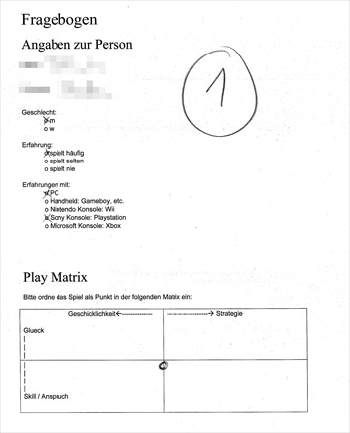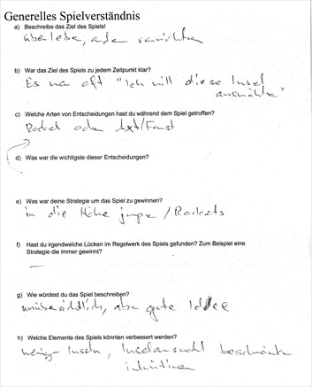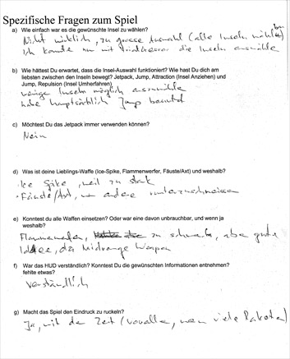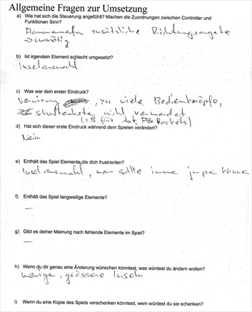

# Our own observations during the testing sessions

During the sessions, we sat beside the players, observed them and made our own notes. These are:

* We will probably need more maps, most of them should have less and bigger islands.
* The controls are generally too complex. The A button has too many functions.
* Player often do not understand where they are, especially after respawning.
* Sometimes, the player seems just to explore randomly? Maybe related to the right front pillar?
* HUD should be moved more towards the corners
* In the beginning, we will need some orientation time before the action starts.
* Menu selection is hardly visible on the CGL lab screen
* The colors should remain when you start another game. Also, multiple players can choose the same color, which is bad. Maybe we should just leave them fixed.
* People thought there might be teams (analogously to Worms Armageddon, e.g.) because players could choose colors.
* Perspective distortion might be too strong
* Multiple players shouted that islands should not leave the screen
* Somebody suggested double-jumps and multiple persons agreed.
* When using the axe, both players fall down.
* Sometimes it seems to be hard to recognize in which direction the player is looking
* Nobody cares about the help screen.
* Orange and pink are hard to distinguish, especially if they stand in the background.
* The game has addiction potential, multiple persons said.
* The game is clearer with 2 players than with 4. The fewer players we have, the more the game ranks on the “skill” rather than the “luck” side in the play matrix.
* Cinematics in the beginning (intro sequence) and the end (winning sequence) are missing.

# Conclusions

The testing session confirmed that our game generally is on the right track: Many of the testers stated that the game play is promising and the graphics look professional. However, there were many problems mentioned due to the alpha nature of the game. Some of them were very specific, but most of them on similar trends. In the following, we will list those problem trends and some possible solutions which we are going to evaluate within the next days:

* The game crashed from time to time in an error 4 and gradually got slower.

*We already started addressing the performance issues by tracking memory allocation and will address the error 4 by logging errors on the X-Box.*

* The ice spike seems to be way too strong. Because of this (and maybe also because it has the nicest visual effect up to now), it was the weapon favored by most.

*This can be addressed in various ways: some testers suggested to only allow the ice spike by a power-up or to let him aim towards the island instead of towards the player. The obvious approach is just to make it much weaker; but this would still allow the popular strategy of just shooting ice spikes from time to time to weaken the enemy. Another idea is to penalize the use of ice spike, e.g. by making it weaker with increasing distance or by making direct hit stronger the less energy you wasted on ice spikes. However, this might be too complex.*

* The game is still too confusing – especially in the beginning. The players are hard to spot and it takes some time to notice on which island a dwarf has been respawned after a death.

*To decrease the initial confusion we will likely implement a camera path before the game starts, so players have time to orientate themselves. During that time, a few big overlaid words might explain the main idea of the game. For respawning, a slow appearance (like when beamed in star trek) using screen-space particles going from the HUD to the player could be implemented. This would make sense since the HUD position is the only invariant per player throughout the game.*

* The controls seem to be too difficult. The overloaded A button confused many testers. Also, island selection appeared to be random to most players.

*We have many functions right now and may have to eliminate some of them to reduce control complexity. The functionality on A could be split onto multiple buttons – but this would again increase complexity. The island selection definitely has to be re-evaluated and maybe constrained onto islands in a certain radius around the player. Some people suggested putting some attack functions on the shoulder buttons which we will also have to evaluate.*

* Players did not like the fact that you cannot jump all the time. Island attraction was rarely used (most players didn’t at all realize it existed). Even fewer used island repulsion or the jetpack.

*We evaluated jumping being the only movement some weeks ago and found it to quirky; but after this feedback, we will have to evaluate jumping as main means of switching islands. But maybe we can also inspire players to use attraction by making it more obvious when an island is being attracted. In general, we will have to find ways to indicate to the player what actions can be performed right now. Also, we will have to make it clear that the jetpack can be used at the time when the player is falling down. A clearer marking on the XZ plane of the current player position while using the jetpack has to be considered.*

* The flame thrower is considered too weak and the stick control is considered unnecessary.

Thus, for the last part of the project, we will be busy implementing missing visualizations and fixing the problems detected during testing.

# Impressions

These two pictures give an overall impression of situations during the testing sessions.

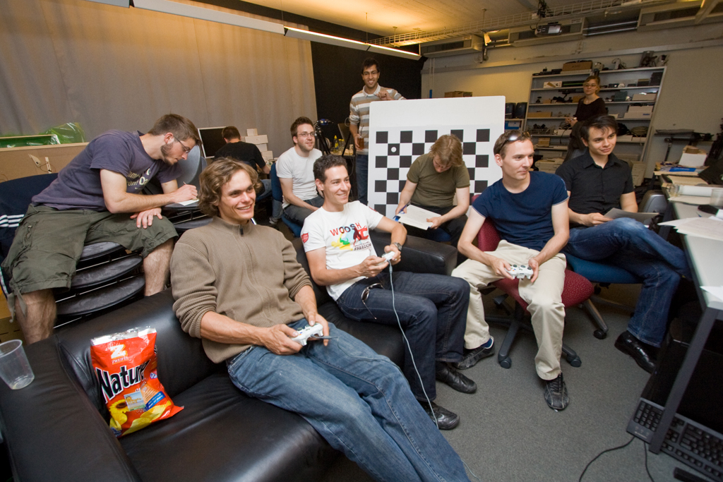

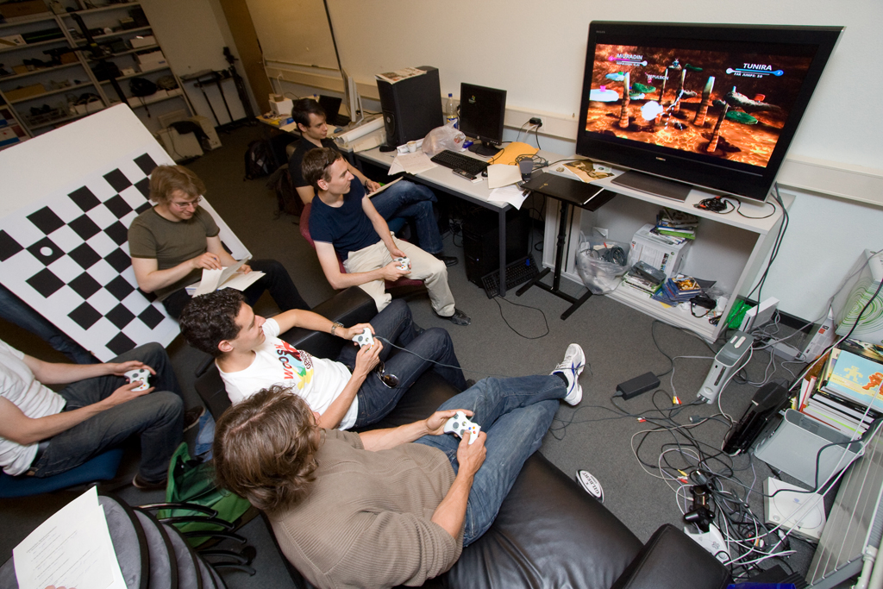

Part 6 – Conclusion

The following describes the last changes in Project Magma before its final incarnation as Magmageddon and our overall conclusions on the project.

# The Product

The final release contains all features from the desirable target, including HDR rendering (ReqG04) and the advanced camera (ReqG02) from the high target. As mentioned in the alpha release, some features, like island attraction (ReqP04), were implemented but later removed if they were too hard to use or didn’t make sense gameplay wise. Likewise, the jetpack has been reduced to a safety measure, which can be used to stop one’s fall when pushed off the island. Similarly, fog was introduced to get calmer overall look. Although it was sometimes hard to get completely rid off features or put already implemented features in the background, doing so was clearly a large improvement in the look and feel of the game, which we were quite happy with at in the end.

## Changes

Since the alpha release the following features were added or improved:

* Power-up respawn (ReqI13) was improved in a way that power-ups now wait in a queue when no island is free to respawn on.
* Player selection (ReqUI04) has been simplified by removing the option to select colors and giving each controller slot a fixed player color.
* The dwarfs from the alpha release have been replaced by the final robot model (ReqP03), which fits much better into the game’s landscape. The models feature animations for jumping, island repulsion, walking, running and hitting.
* A moving camera (ReqG02) has been implemented, which keeps the main action in focus: it zooms in on the players and all islands which they can jump too. This way, some islands may be out of the screen, but never the ones you can interact with.
* The movement of the islands (ReqI04) has been improved, so it is smoother and better reacts to collision events.
* The placeholder sounds used for all previous releases were replaced by better suiting and normalized ones.

## Features

* 4 robots fighting in death match mode
* 4 different maps, with their own look and playing style
* 3 attacks: ice spike (long range), flamethrower (medium range) and pushing (short range)
* 3 means to navigate between islands: jump (short range), repulsion (long range) and jetpack (backup)
* Beautifully designed islands hovering amongst pillars
* A cave full of realistically animated lava with snow dropping in from above
* Various sophisticated lighting and particle effects

## The Feel

The game play has undergone some major changes since the first playable version and evolved from a simple prototype, where your main goal was not to fall down while navigating between the islands, to a polished product which gives players a range of choices how to defeat their opponents.

A round of Magmageddon starts out with up to four robots getting dropped into the cave onto hovering islands. Each player controls one such robot, distinguishable by its color. The slow spawn animation gives the players time to spot their robot on the field. When the last robot has landed on an island, the game starts.

Now the players have the main choice between going mano-a-mano (or roboto-a-roboto?) with another player or us one of the ranged weapons (flamethrower or ice spike) to take him out. Whereas directly engaging another robot is free and can result in him getting pushed down the island, ranged attacks cost energy – and you cannot directly kill an opponent with your initial amount of energy. So when energy runs out you either have to wait for it to slowly recharge or find an energy power-up. Waiting, though, may not be the best idea as the other players will very probably not just sit back and relax. They’d rather directly charge at you and push you down your island. If you’re skilled, though, you may still be able to activate your jetpack before falling into the lava and fly to safety. On the other hand, if your opponent is skilled to, he will throw an ice spike at you beforehand or while you’re in air, which will deactivate your jetpack. Had he been the one pushed down, you couldn’t have stopped him at all, being low on energy from your use of ranged chicken-weapons before. But then again, he may be low on energy too, because moving the islands to navigate through the cave needs energy too.

In the end, the essence of the game is to find the balance between not using energy at all and using it up too much so you don’t have any left to navigate or throw ice spikes to stop an opponent’s jetpack in time.

# Statistics

In preparation to writing this document and also for the final presentation we sampled some statistics about the work that we have done. We checked out every 100th revision from the subversion repository and created an excel sheet containing the most important numbers for both c# code and effects code. We would like to point out some interesting facts that we discovered while analyzing the statistics:

* Only the first half of all subversion revisions (in total 1600) has been submitted until end of April. This means that we checked in more than 800 revisions in may, while we implemented testing feedback.
* Another indication that we have been fine tuning small details is that we wrote most of the code (nearly 20’000 lines of code) until the end of April. Only small parts have been changed or added during the final phase of the project.
* In general our code seems to be well-sized. Overall we had an average of about 100 lines of code per file. We think that this is a reasonable number and statistics confirm that we never drifted much from this ratio.
* Comparing the c# statistic with the effect statistic it is easy to see that the project started with a prototype concentrating on the core architecture and the game play. Graphics effects have been implemented after about the first half of the project.
* The loss of code between 04/02/2009 and 04/09/2009 seemed to be a bit weird first because we never deleted large parts of the code from our game and we also did not count in any external library. After a bit of research on the subversion log we discovered that this was due to the fact that the subversion plugin for visual studio which we used did not commit file deletes. So chunk files accumulated and were deleted during the questioned time period.

# Conclusion

## Overall

We think our project is quite a success.

First and foremost, our vision was to create a game with moving platforms, thus making the game interesting through an ever changing “playfield”. In addition we wanted the game to be a contrast between the hot Lava from below and the cold ice from above. We think that after a lot of testing we succeeded in bringing this experience to the player although it still needs some time to get accustomed to the controls.

Besides the actual game the project was also a success in other areas: The project involved a lot of teamwork, which we managed to achieve. At the beginning we needed some time to learn how the other team members think about different areas and problems within the game. But after that the communication was always straight and clear and it was clear to every member of the team how the others thought about the topics in question. Even though our discussions have been intense and heated sometimes, we think this is the better way than to always be polite and leave the other person in the dark on what you are really thinking.

Additionally, from a project management view, we were on schedule most of the time. Our aim was to meet all the milestones and to move features dynamically based on the experience gained by previous milestones reached. This means that we sometimes moved features to later milestones in favour of more important features that we needed earlier than expected. The milestones themselves have been delayed by at most one day which is, as we think, a good result.

Finally, the work with external artists, which was planned from the very beginning, paid off in the end. Of course a lot of time went into discussions with the artists on how to model different aspects of the game. It was also uncertain for quite some time if we would ever get a player model and we prepared some replacement models ourselves. In the end we received everything we needed and were able to show a game with high quality, professional models.

Considering the complexity of a project like Magmageddon and looking at the aspects mentioned above we think that the project overall went quite smoothly, with some hard, but solvable problems in between.

## Janick Bernet

My personal goal was to create a game which is fun to play with your colleagues and which contains some novel ideas. To achieve this, we had to experiment with a lot of different weapons and types of movements and had to tune hundreds of parameters to get the working features balanced right. I myself especially had many different approaches for the various collision-responses to experiment with, as depending on the objects involved and their movement a different type of collision-response may be appropriate. For instance for an island colliding with a pillar, you can simply reflect the island’s velocity at the collision-normal, while for a player using his jetpack this doesn’t work. It was sometimes hard to get rid of an algorithm which doesn’t create pleasing results, but was a huge effort to implement, or to even drop some features, such as island attraction, which may have had many hours of work dedicated to them, completely. But in the end it is a necessary to get a streamlined and balanced game play and I think we did a very good job at that.

Overall, working on a game was a great experience and definitely one of the high points of my ETH career. Although time consuming, having one’s own game to show to people – and to watch them even enjoying it – is extremely rewarding. Still, I should warn future Student that it is not the best idea to also do Compiler Design I in the same semester. And it gets even harder if you manage to get your system disc to break down three weeks before the semester’s end…

## Dominik Käser

It has always been clear that the game laboratory will be one of my most challenging classes at ETH. Retrospectively, it was a big journey indeed. On one hand, I could fill my knowledge gaps in the areas of GPU programming, 3D modeling and software architecture using C#. On the other hand, though, it was important to get the experience of working full-time on a reasonably-sized project for multiple months with two team members. Since we all had quite strong (and not always agreeing) opinions about both design and implementation, this raised several challenges which we were confronted with. It turns out that meeting regularly in real-life is a crucial aspect to avoid misunderstanding and inefficient online chats. Another point is that having a bugtracking system is essential.

Our goal in "Magmageddon" was to obtain a visually appealing game which was fun or even addictive to play and running smoothly on the X-Box. As three very motivated people whose teamwork got gradually stronger with time, I think we successfully reached this goal and I hope that we can go beyond the current result at some point. First, though, a great deal of holidays will be needed!

## Christian Oberholzer

I always wanted to visit the game development laboratory from the very first moment on that I arrived at ETH. Because of that I also had a lot of expectations both in terms of the course itself and also in the end result that we had envisioned. And of course in the end it was hard to fulfil the expectations.

In terms of the project itself I think everything is nicely summarized in the overall conclusion above. But regarding the course itself I would like to mention some points.

First of all I imagined the course to be quite different from what it actually was. This was mainly due to the advertisement presentations that have been hold at various occasions by different representatives of the computer graphics laboratory. For example I expected that there is a weekly meeting in the room with the large television to play all the games. But in fact this was never the case. It would be a cool idea to arrange such a meeting by the organizers of the course. Even if it would not be mandatory I think a lot of the course participants would meet there, strengthening the cooperation in between teams.

I also think that targeting the Xbox 360 using XNA is a double-edged sword. On the one hand it ensures that everyone starts off from a secure point. It is also quite motivating developing for the Xbox with a huge coolness factor. On the other hand it is also very restrictive. Some game genres like strategy games are nearly impossible to implement on a console. Personally I would have preferred to be open to choose the target platform depending on the game to be implemented.

All in all we had sometimes an exhausting, but always exciting time developing the game. And most importantly: The result is really cool!

# Screenshots

